Batch: Roll No.:

Experiment No.1

Title: Understanding real-world problem and design of Enhanced Entity-Relationship (ER and EER) Model

Objective: To comprehend the data requirements of the application and design the Entity-Relationship (ER) diagram and EER diagram for the database
______________________________________________________________________
Expected Outcome of Experiment:

CO1: Comprehend the features of relational database management systems.
_____________________________________________________________________
Books/ Journals/ Websites referred:

- G. K. Gupta :”Database Management Systems”, McGraw – Hill
- Korth, Slberchatz, Sudarshan : “Database Systems Concept”, 6th Edition , McGraw Hill
- Elmasri and Navathe, “Fundamentals of Database Systems”, 5thEdition, PEARSON Education.
______________________________________________________________________
Pre Lab/ Prior Concepts:

Dia Software: software to Design ER Model

Dia is one of the convenient open source tool which runs on multiple platforms including Linux, Windows and MacOS.Dia has a number of "sheets" each of which includes diagram objects for different modeling tools, such as UML, ER diagrams, flowcharts, etc.

ER Model:

The ER data model was developed to facilitate the database design by allowing specification of an enterprise schema that represents the overall logical structure of the database. The ER model is one of the several data models. The semantic aspect of the model lies in its representation of the meaning of the data. The ER model is very useful many database design tools drawn on concepts from the ER model. The ER model employs 3 basic notations: entity set, relationship set and attributes.

Example Case Study: List the data requirements for the database of the company Case Study : A company which keeps track of employee, department and projects.
The database designers provide the following description

  - The company is organized into departments. Each department has a unique name, unique number, and particular employee to manage the department. We keep track of the start date and the employee begins managing the department. The department has several locations.
  - The department controls a number of projects each of which has a unique name, unique number and a single location.
  - We store each employee's name, social security number, address, salary, gender and DOB. An employee is assigned one department but may work on several projects which are not necessarily controlled by the same department. We keep track of the department each employee works on each project and for insurance purposes. We keep each dependents first name, Gender, DOB and relation.

Procedure for doing the ER diagram experiment

- Identifying the Entities-Strong and weak entities ( Nouns from the problem definition )
Based on the requirements, we can identify four initial entity types in the COMPANY database:
  - DEPARTMENT
  - PROJECT
  - EMPLOYEE
  - DEPENDENT

- Identify attributes of the Entity- keys, partial key, simple, composite, multivalued, derived ( characteristics of the entities)

The initial attributes shown are derived from the requirements description

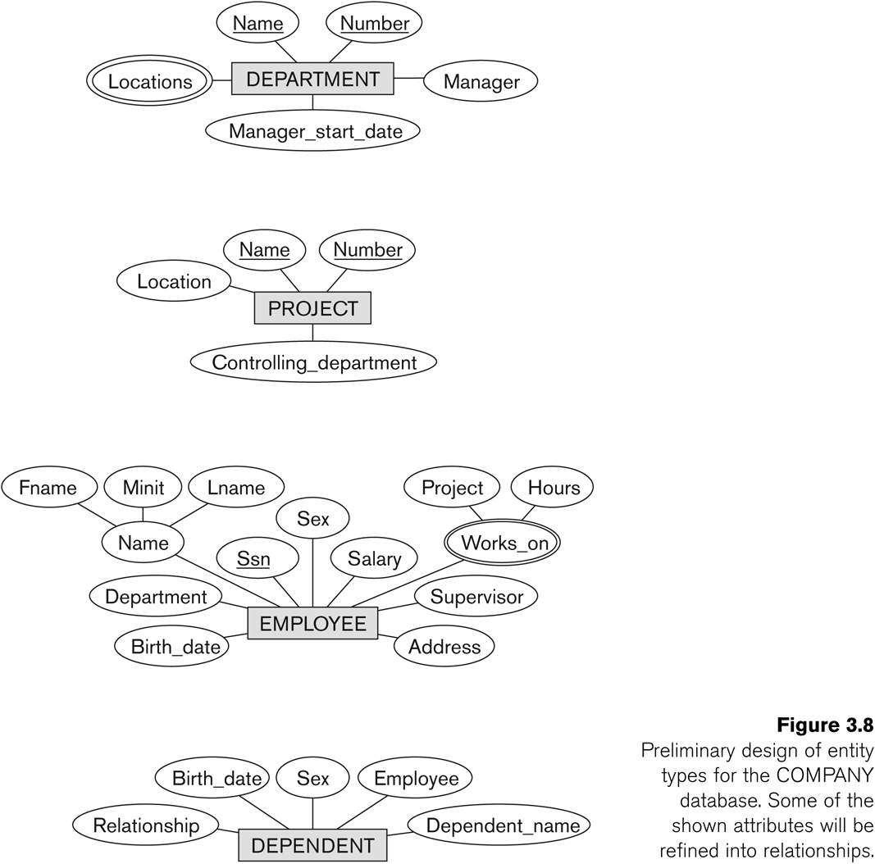

- Identify relationships ( verbs )

A relationship relates two or more distinct entities with a specific meaning.
  - For example, EMPLOYEE John Smith works on the ProductX PROJECT, or EMPLOYEE Franklin Wong manages the Research DEPARTMENT.

Relationships of the same type are grouped or typed into a relationship type.
  - For example, the WORKS_ON relationship type in which EMPLOYEEs and PROJECTs participate, or the MANAGES relationship type in which EMPLOYEEs and DEPARTMENTs participate.

The degree of a relationship type is the number of participating entity types.
  - Both MANAGES and WORKS_ON are binary relationships.

In ER diagrams, we represent the relationship type as follows:
  - Diamond-shaped box is used to display a relationship type
  - Connected to the participating entity types via straight lines

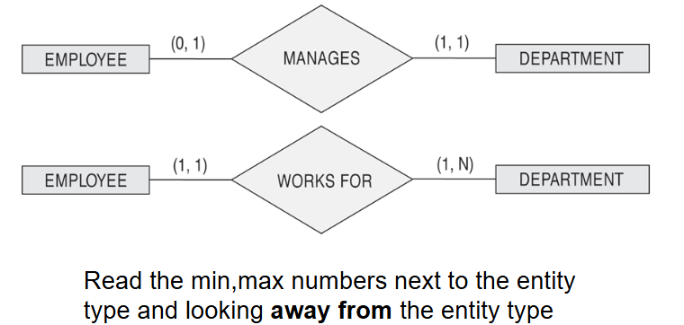

Listed below with their participating entity types:
  - WORKS_FOR (between EMPLOYEE, DEPARTMENT)
  - MANAGES (also between EMPLOYEE, DEPARTMENT)
  - CONTROLS (between DEPARTMENT, PROJECT)
  - WORKS_ON (between EMPLOYEE, PROJECT)
  - SUPERVISION (between EMPLOYEE (as subordinate), EMPLOYEE (as supervisor))
  - DEPENDENTS_OF (between EMPLOYEE, DEPENDENT)

ER- Diagram for company Case Study Database:

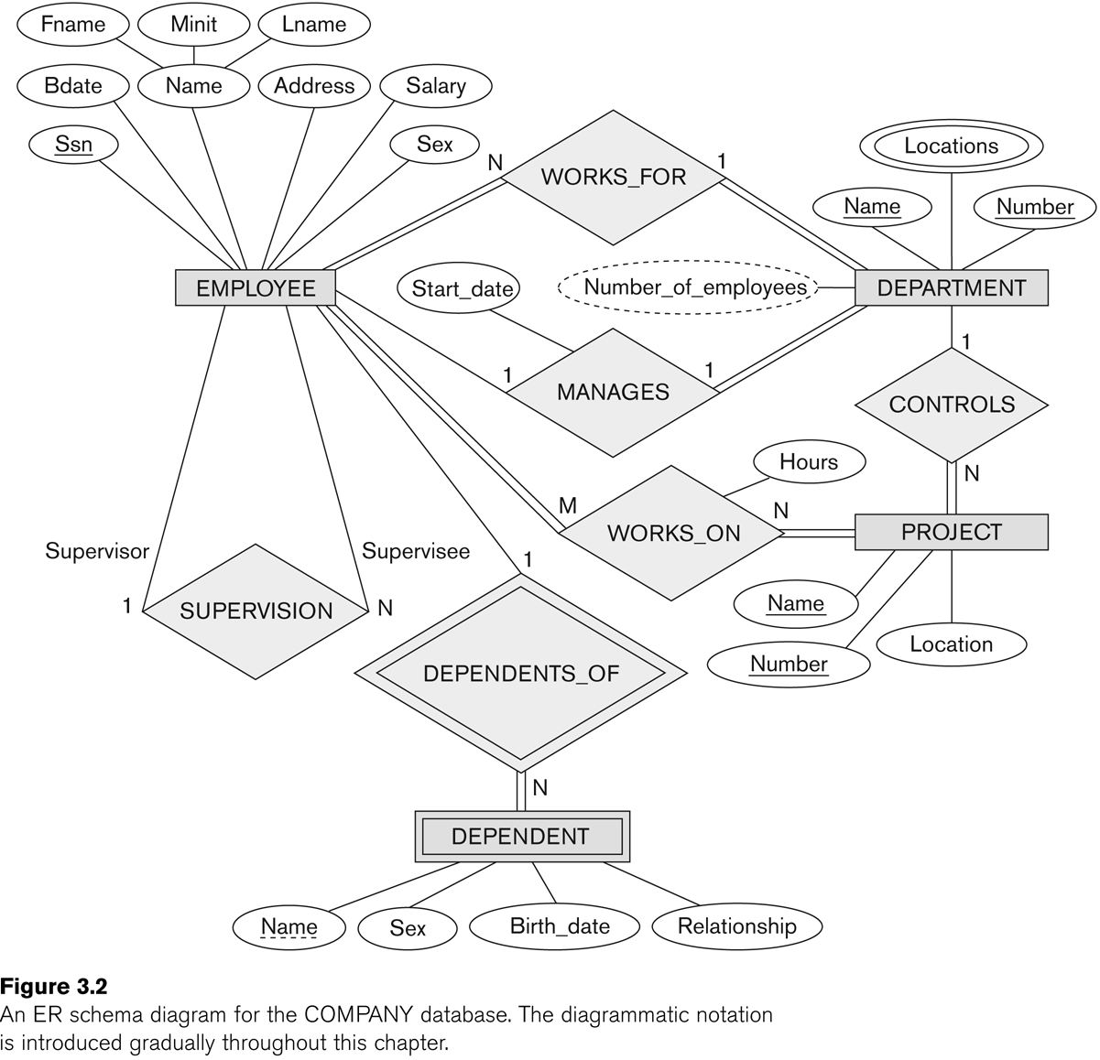

Identify the structural constraints of the relationship (cardinality ratio, participation constraints)

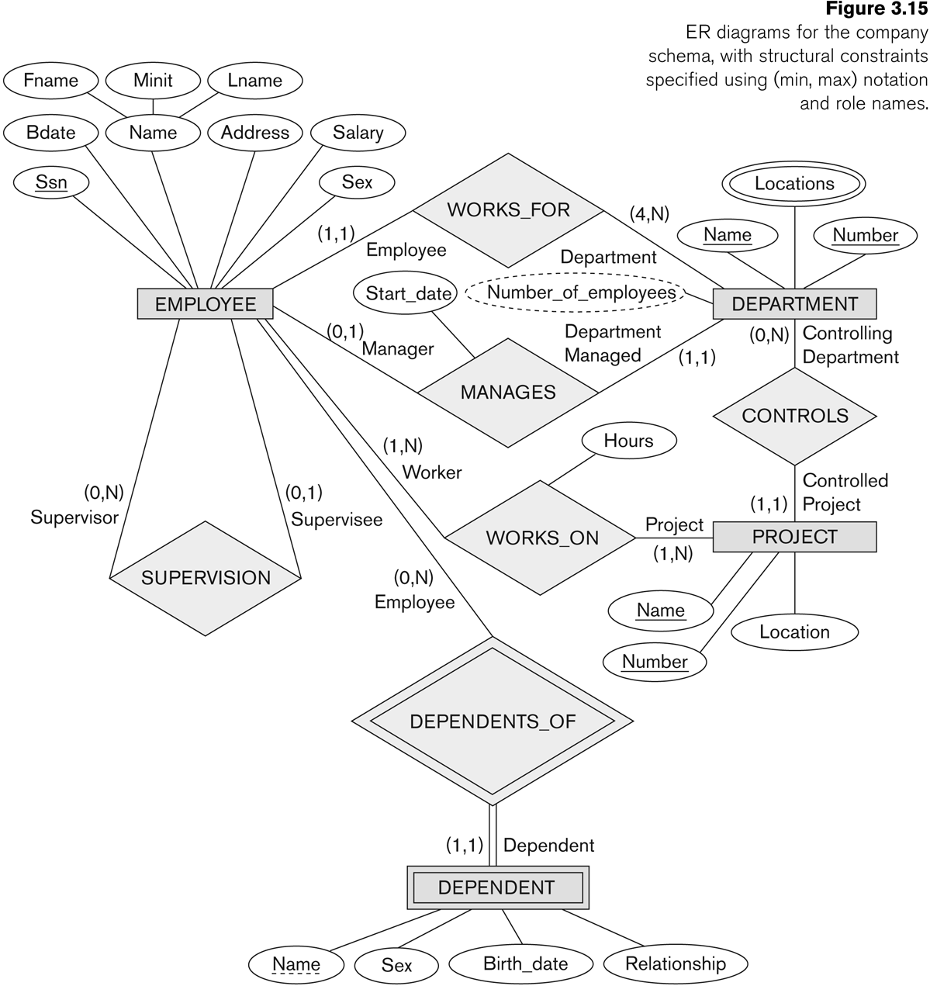

Extended Entity Relationship Diagram:
The EER model includes all of the concepts introduced by the ER model. Additionally it includes the concepts of a subclass and superclass (Is-a), along with the concepts of specialization and generalization. Furthermore, it introduces the concept of a union type or category, which is used to represent a collection of objects that is the union of objects of different entity types. EER model also includes EER diagrams that are conceptual models that accurately represent the requirements of complex databases.

Example Case Study: List the data requirements for the database of the company which keeps track of the company employee, department and projects. The database designers provide the following description

Procedure for doing the EER diagram experiment
EER stands for Enhanced ER or Extended ER
EER Model Concepts
Includes all modeling concepts of basic ER
Additional concepts:
- subclasses/superclasses
- specialization/generalization
- categories (UNION types)
- attribute and relationship inheritance
These are fundamental to conceptual modeling
The additional EER concepts are used to model applications more completely and more accurately
EER includes some object-oriented concepts, such as inheritance

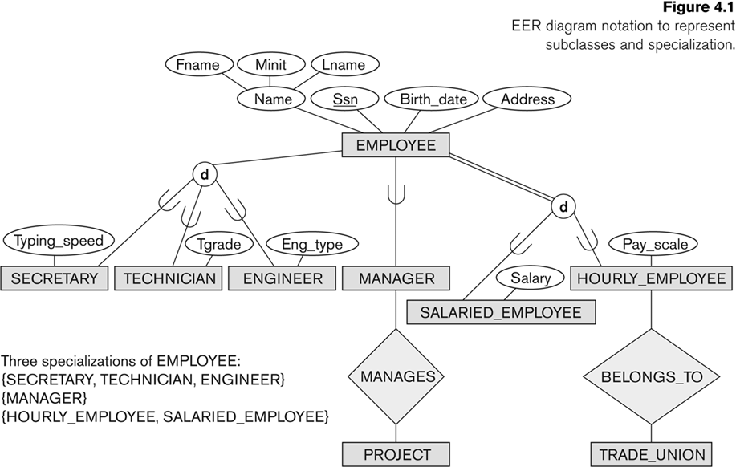

Generalization
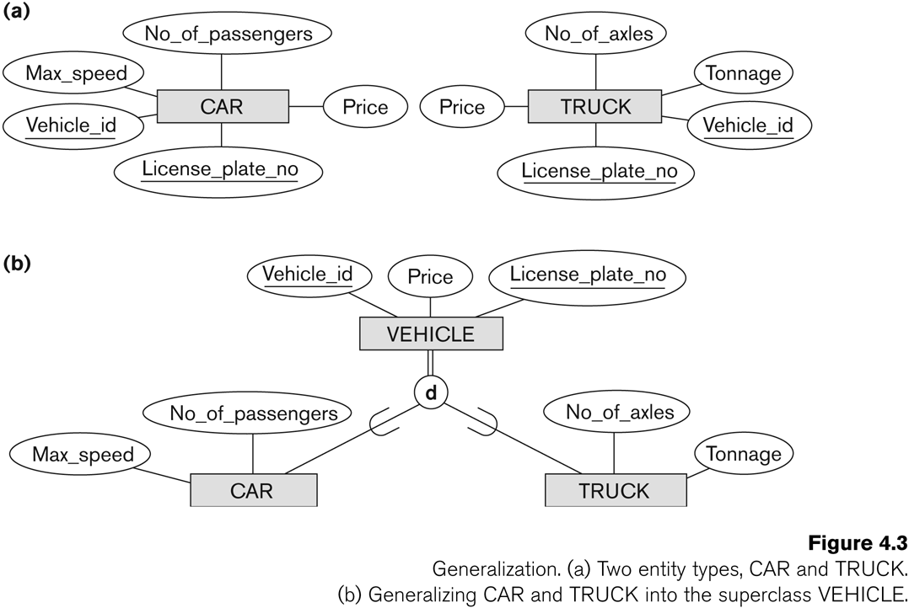

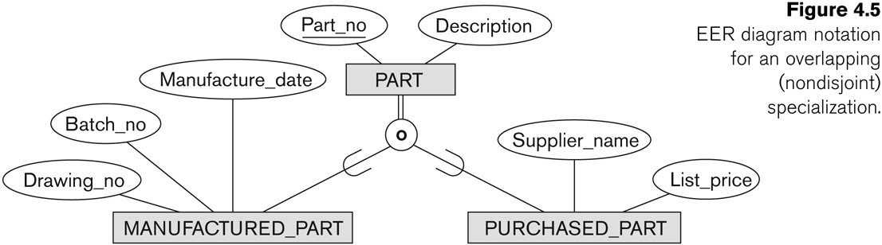

C: Categories and Union
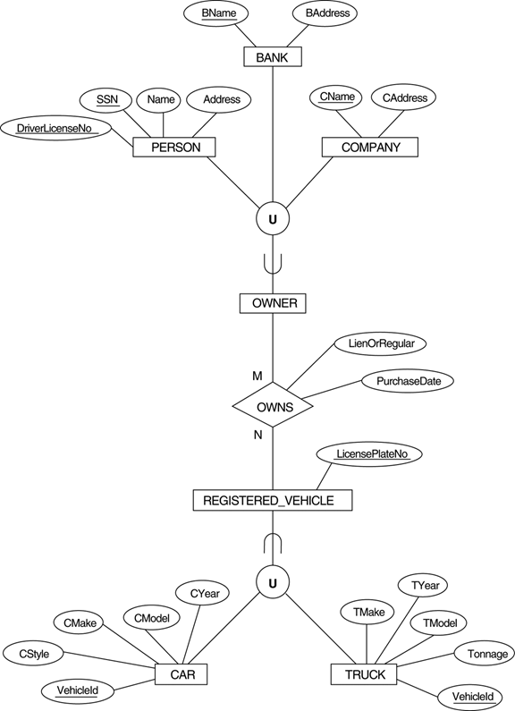

Conclusion:

Post lab Descriptive Questions

- What is a key attribute? Explain with examples
- Explain participation constraints with examples.
- Discuss the concept of aggregation. Give an example.

